/*****************************************************************************

To be the apostrophe which changed "Impossible" into "I'm possible"!

POC code of book "Vulnerability Exploit and Analysis Technique"

file name : stack_show.c

author : failwest

date : 2006.9.23

description : used as a demo to show how stack works

Noticed : just for debugging and stack watching

version : 1.0

E-mail : failwest@gmail.com

Only for educational purposes enjoy the fun from exploiting :)

******************************************************************************/

int func_B(int arg_B1, int arg_B2)

{

int var_B1, var_B2;

var_B1=arg_B1+arg_B2;

var_B2=arg_B1-arg_B2;

return var_B1*var_B2;

}

int func_A(int arg_A1, int arg_A2)

{

int var_A;

system("pause");

var_A = func_B(arg_A1,arg_A2) + arg_A1 ;

return var_A;

}

int main(int argc, char **argv, char **envp)

{

int var_main;

system("pause");

var_main=func_A(4,3);

system("pause");

return 0;

}

**小修改了一下代码，适合做笔记也适合观测**  
**生成exe什么的就不再说了**  
**载入OD**

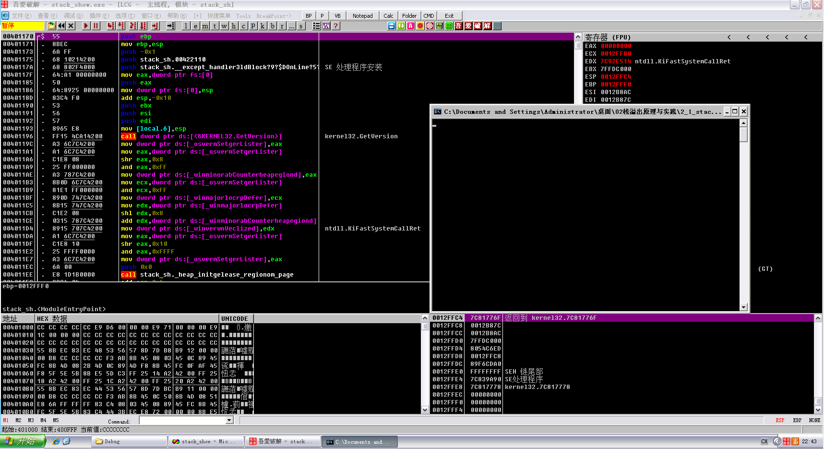

**F8单步走下去,这三次明显的压栈操作，就是把main函数的三个参数压入栈里，从名字也可以看出来三个参数的压栈顺序**

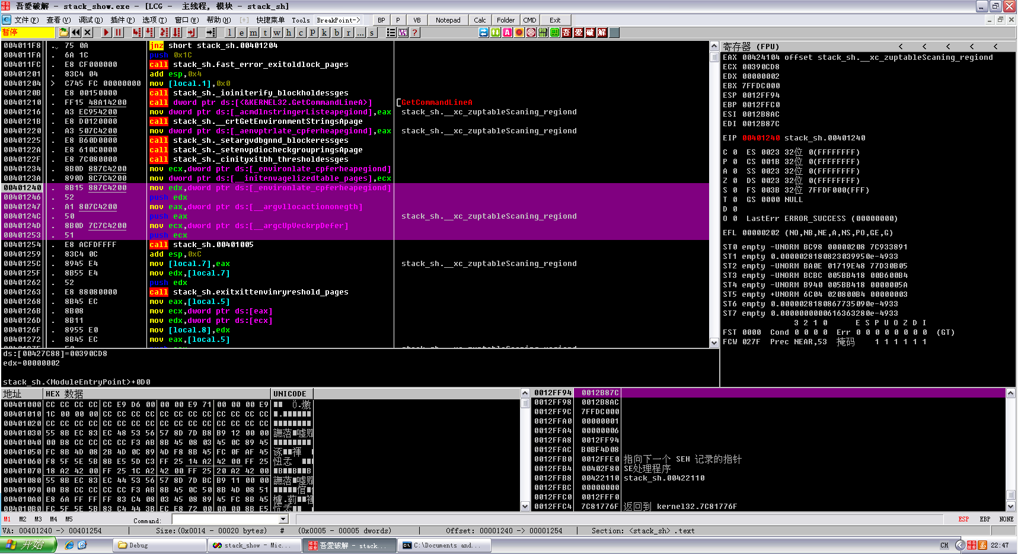

**然后下面的call就是调用main函数了**  
**F7跟进去，发现三个jmp**

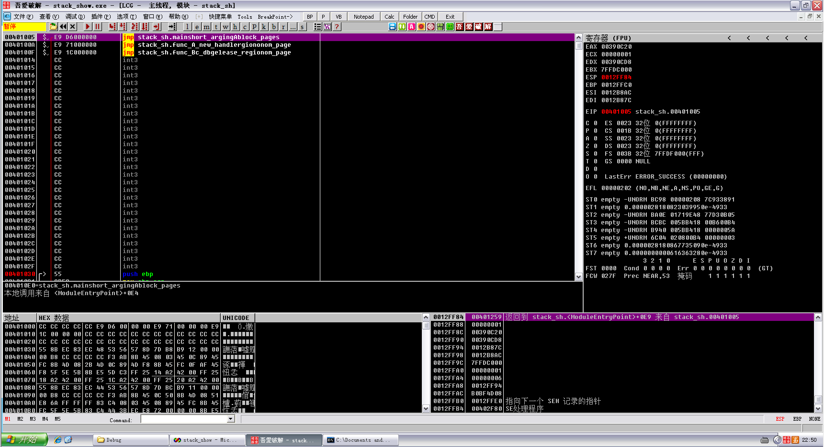

**F8单步走啊走，碰到自个儿加的暂停，停下来观察一下，这里就是main函数的领空了**

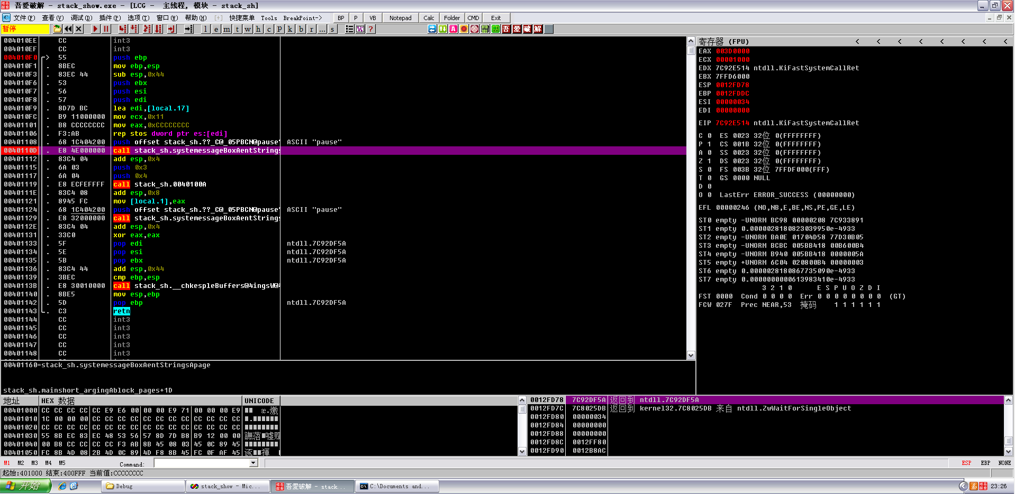

**想找到第一个pause的位置，直接F9，然后暂停，按k，然后就可以看到调用了，右键显示调用即可，然后先给下个断点，不会下断点的不要抱我，我不要你了：）**  
**结合刚刚的三个jmp，然后分析这三个片段，可以猜测这三个片段就是三个函数，继续往下分析**

00401005 $ /E9 E6000000 jmp stack_sh.mainshort_argingAblock_page>

0040100A $ |E9 71000000 jmp stack_sh.func_A_new_handlergiononom_>

0040100F $ |E9 1C000000 jmp stack_sh.func_Bc_dbgelease_regionom_>

00401014 |CC int3

00401015 |CC int3

00401016 |CC int3

00401017 |CC int3

00401018 |CC int3

00401019 |CC int3

0040101A |CC int3

0040101B |CC int3

0040101C |CC int3

0040101D |CC int3

0040101E |CC int3

0040101F |CC int3

00401020 |CC int3

00401021 |CC int3

00401022 |CC int3

00401023 |CC int3

00401024 |CC int3

00401025 |CC int3

00401026 |CC int3

00401027 |CC int3

00401028 |CC int3

00401029 |CC int3

0040102A |CC int3

0040102B |CC int3

0040102C |CC int3

0040102D |CC int3

0040102E |CC int3

0040102F |CC int3

00401030 >/> |55 push ebp

00401031 |. |8BEC mov ebp,esp

00401033 |. |83EC 48 sub esp,0x48

00401036 |. |53 push ebx

00401037 |. |56 push esi

00401038 |. |57 push edi

00401039 |. |8D7D B8 lea edi,[local.18]

0040103C |. |B9 12000000 mov ecx,0x12

00401041 |. |B8 CCCCCCCC mov eax,0xCCCCCCCC

00401046 |. |F3:AB rep stos dword ptr es:[edi]

00401048 |. |8B45 08 mov eax,[arg.1]

0040104B |. |0345 0C add eax,[arg.2]

0040104E |. |8945 FC mov [local.1],eax

00401051 |. |8B4D 08 mov ecx,[arg.1]

00401054 |. |2B4D 0C sub ecx,[arg.2]

00401057 |. |894D F8 mov [local.2],ecx

0040105A |. |8B45 FC mov eax,[local.1]

0040105D |. |0FAF45 F8 imul eax,[local.2] ; kernel32.7C802608

00401061 |. |5F pop edi ; ntdll.7C92DF5A

00401062 |. |5E pop esi ; ntdll.7C92DF5A

00401063 |. |5B pop ebx ; ntdll.7C92DF5A

00401064 |. |8BE5 mov esp,ebp

00401066 |. |5D pop ebp ; ntdll.7C92DF5A

00401067 \. |C3 retn

00401068 |CC int3

00401069 |CC int3

0040106A |CC int3

0040106B |CC int3

0040106C |CC int3

0040106D |CC int3

0040106E |CC int3

0040106F |CC int3

00401070 |CC int3

00401071 |CC int3

00401072 |CC int3

00401073 |CC int3

00401074 |CC int3

00401075 |CC int3

00401076 |CC int3

00401077 |CC int3

00401078 |CC int3

00401079 |CC int3

0040107A |CC int3

0040107B |CC int3

0040107C |CC int3

0040107D |CC int3

0040107E |CC int3

0040107F |CC int3

00401080 >/> |55 push ebp

00401081 |. |8BEC mov ebp,esp

00401083 |. |83EC 44 sub esp,0x44

00401086 |. |53 push ebx

00401087 |. |56 push esi

00401088 |. |57 push edi

00401089 |. |8D7D BC lea edi,[local.17]

0040108C |. |B9 11000000 mov ecx,0x11

00401091 |. |B8 CCCCCCCC mov eax,0xCCCCCCCC

00401096 |. |F3:AB rep stos dword ptr es:[edi]

00401098 |. |68 1C404200 push offset stack_sh.??_C@_05PBCN@pause?>; ASCII "pause"

0040109D |. |E8 BE000000 call stack_sh.systemessageBoxAentStrings>

004010A2 |. |83C4 04 add esp,0x4

004010A5 |. |8B45 0C mov eax,[arg.2]

004010A8 |. |50 push eax

004010A9 |. |8B4D 08 mov ecx,[arg.1]

004010AC |. |51 push ecx

004010AD |. |E8 5DFFFFFF call stack_sh.0040100F

004010B2 |. |83C4 08 add esp,0x8

004010B5 |. |0345 08 add eax,[arg.1]

004010B8 |. |8945 FC mov [local.1],eax

004010BB |. |8B45 FC mov eax,[local.1]

004010BE |. |5F pop edi ; ntdll.7C92DF5A

004010BF |. |5E pop esi ; ntdll.7C92DF5A

004010C0 |. |5B pop ebx ; ntdll.7C92DF5A

004010C1 |. |83C4 44 add esp,0x44

004010C4 |. |3BEC cmp ebp,esp

004010C6 |. |E8 A5010000 call stack_sh.__chkespleBuffers@4ingsW@4>

004010CB |. |8BE5 mov esp,ebp

004010CD |. |5D pop ebp ; ntdll.7C92DF5A

004010CE \. |C3 retn

004010CF |CC int3

004010D0 |CC int3

004010D1 |CC int3

004010D2 |CC int3

004010D3 |CC int3

004010D4 |CC int3

004010D5 |CC int3

004010D6 |CC int3

004010D7 |CC int3

004010D8 |CC int3

004010D9 |CC int3

004010DA |CC int3

004010DB |CC int3

004010DC |CC int3

004010DD |CC int3

004010DE |CC int3

004010DF |CC int3

004010E0 |CC int3

004010E1 |CC int3

004010E2 |CC int3

004010E3 |CC int3

004010E4 |CC int3

004010E5 |CC int3

004010E6 |CC int3

004010E7 |CC int3

004010E8 |CC int3

004010E9 |CC int3

004010EA |CC int3

004010EB |CC int3

004010EC |CC int3

004010ED |CC int3

004010EE |CC int3

004010EF |CC int3

004010F0 >/> \55 push ebp

004010F1 |. 8BEC mov ebp,esp

004010F3 |. 83EC 44 sub esp,0x44

004010F6 |. 53 push ebx

004010F7 |. 56 push esi

004010F8 |. 57 push edi

004010F9 |. 8D7D BC lea edi,[local.17]

004010FC |. B9 11000000 mov ecx,0x11

00401101 |. B8 CCCCCCCC mov eax,0xCCCCCCCC

00401106 |. F3:AB rep stos dword ptr es:[edi]

00401108 |. 68 1C404200 push offset stack_sh.??_C@_05PBCN@pause?>; ASCII "pause"

0040110D |. E8 4E000000 call stack_sh.systemessageBoxAentStrings>

00401112 |. 83C4 04 add esp,0x4

00401115 |. 6A 03 push 0x3

00401117 |. 6A 04 push 0x4

00401119 |. E8 ECFEFFFF call stack_sh.0040100A

0040111E |. 83C4 08 add esp,0x8

00401121 |. 8945 FC mov [local.1],eax

00401124 |. 68 1C404200 push offset stack_sh.??_C@_05PBCN@pause?>; ASCII "pause"

00401129 |. E8 32000000 call stack_sh.systemessageBoxAentStrings>

0040112E |. 83C4 04 add esp,0x4

00401131 |. 33C0 xor eax,eax

00401133 |. 5F pop edi ; ntdll.7C92DF5A

00401134 |. 5E pop esi ; ntdll.7C92DF5A

00401135 |. 5B pop ebx ; ntdll.7C92DF5A

00401136 |. 83C4 44 add esp,0x44

00401139 |. 3BEC cmp ebp,esp

0040113B |. E8 30010000 call stack_sh.__chkespleBuffers@4ingsW@4>

00401140 |. 8BE5 mov esp,ebp

00401142 |. 5D pop ebp ; ntdll.7C92DF5A

00401143 \. C3 retn

**然后看代码**

int main(int argc, char **argv, char **envp)

{

int var_main;

system("pause");

var_main=func_A(4,3);

system("pause");

return 0;

}

**对比代码，可以看出，当前断点的call调用的的确是system(“pause”)，下面的push 3和push 4为func_A的参数，那么在压入3和4参数之后就会进行调用call，那么就继续运行，然后回车，回车后程序就继续运行到了第二个暂停，同样点击暂 停，然后按k，右击显示调用**

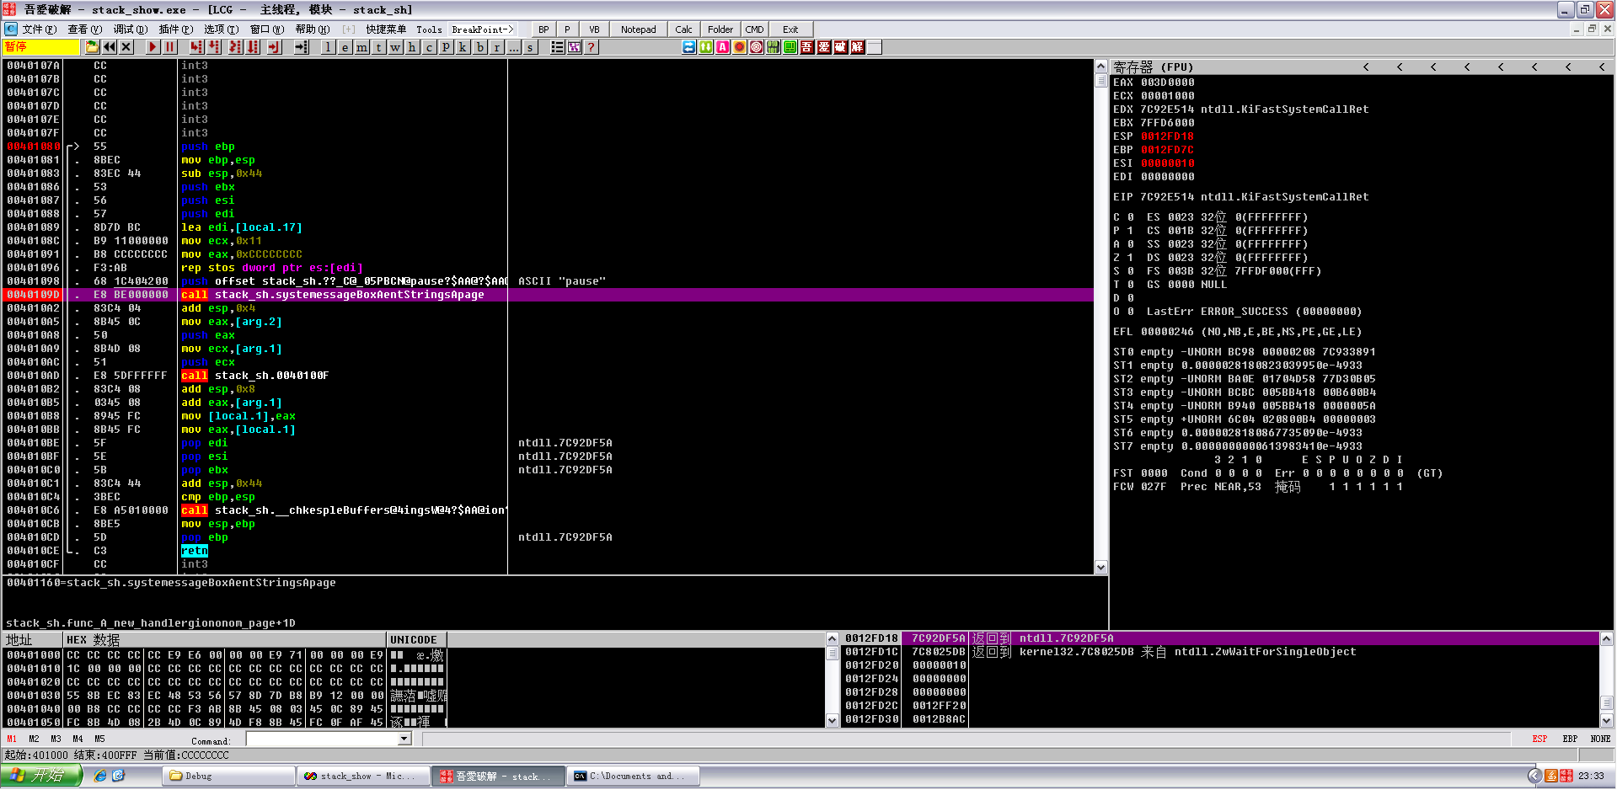

var_A = func_B(arg_A1,arg_A2) + arg_A1 ;

**调用前的压栈操作**

004010A5 |. 8B45 0C mov eax,[arg.2]

004010A8 |. 50 push eax

004010A9 |. 8B4D 08 mov ecx,[arg.1]

004010AC |. 51 push ecx